1. **Write a program to implement ASCII addition.**

.model small

.data

a db '1234'

len1 db $-a

b db '9876'

len2 db $-b

result db 05 dup(?)

len3 db $-result

.code

main proc near

mov ax,@data

mov ds,ax

lea bx,a

add bl,len1

mov si,bx

lea bx,b

add bl,len2

mov di,bx

dec si

dec di

dec len3

lea bx,result

add bl,len3

mov cl,len1

mov ax,0h

l1:

mov al,[si]

mov dl,[di]

cmp ah,00h

je skip

mov ah,0h

inc al

skip:

add al,dl

aaa

or al,30h

mov [bx],al

dec bx

dec si

dec di

loop l1

cmp ah,00h

je over

mov [bx],31h

jmp finish

over:

mov [bx],30h

finish:

mov ax,04ch

int 21h

endp

end

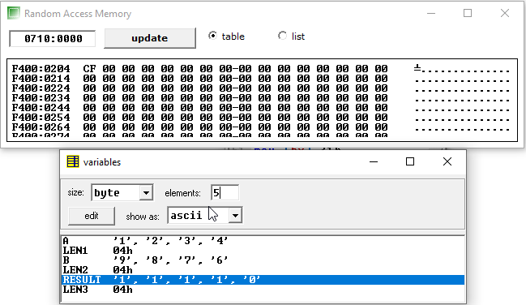

1. **Write a program to implement ASCII subtraction.**

.model small

.data

a db '9934'

len1 db $-a

b db '9876'

len2 db $-b

result db 04 dup(?)

len3 db $-result

.code

main proc near

mov ax,@data

mov ds,ax

lea bx,a

add bl,len1

mov si,bx

lea bx,b

add bl,len2

mov di,bx

dec si

dec di

dec len3

lea bx,result

add bl,len3

mov cl,len1

mov ax,0h

l1:

mov al,[si]

mov dl,[di]

cmp ah,00h

je skip

dec al

mov ah,00h

skip:

sub al,dl

aas

or al,30h

mov [bx],al

dec bx

dec si

dec di

loop l1

mov ax,04ch

int 21h

endp

end

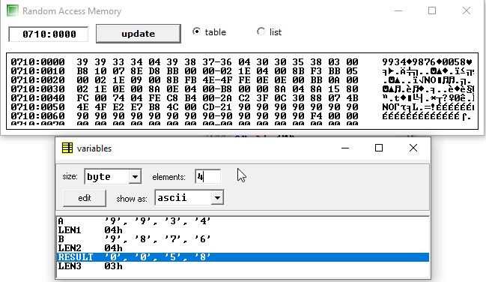

1. **Write a program to implement ASCII multiplication.**

.model small

.data

num1 db '49'

l1 dw $-num1

num2 db '9'

l2 db $-num2

result db 03 dup(?)

len db $-result

.code

main proc near

mov ax,@data

mov ds,ax

lea bx,num1-1

add bx,l1

mov si,bx

mov bx,0h

lea bx,num2-1

add bl,l2

mov di,bx

mov ax,0h

mov cx,0h

mov dx,0h

lea bx,result

add bl,len

mov dl,[di]

and dl,0fh

lo2:

dec l1

mov al,[si]

and al,0fh

mul dl

aam

add al,dh

aaa

mov dh,ah

or al,30h

mov [bx],al

dec bx

dec si

cmp l1,00h

je over

jmp lo2

over:

or dh,30h

mov [bx],dh

mov ax,04ch

int 21h

endp

end

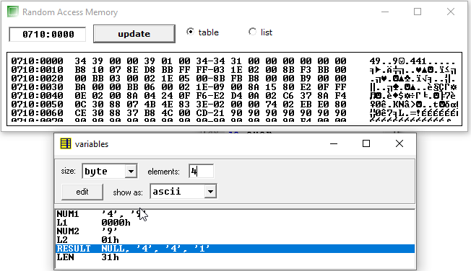

1. **Write a program to implement ASCII division.**

.model small

.data

num1 db '2156'

len db $-num1

num2 db '5'

quo db len dup(?)

len1 db $-quo

rem db ?

.code

main proc near

mov ax,@data

mov ds,ax

mov ax,0h

lea si,num1

lea di,quo

mov bl,num2

and bl,00fh

l1:

dec len

mov al,[si]

and al,00fh

aad

div bl

or al,30h

mov [di],al

inc di

inc si

cmp len,00h

je over

jmp l1

over:

or ah,30h

mov rem,ah

mov ax,04ch

int 21h

endp

end

